Project Planning Phase
Project Planning Template (Product Backlog, Sprint Planning, Stories, Story points)
Date | 30 September 2026
Team ID | SWTID-2026-8157
Project Name | BlogNest – AI-Powered Blog Content Generation & Management Platform
Maximum Marks | 5 Marks

Product Backlog, Sprint Schedule, and Estimation (4 Marks)
Product backlog and sprint schedule for BlogNest (3 sprints of 14 days, 63 story points).
Sprint | Functional Requirement (Epic) | User Story Number | User Story / Task | Story Points | Priority | Team Members
Sprint-1 | Project Architecture & Setup | USN-1 | As a developer, I set up the Node.js project, folder structure, dependencies and .env configuration. | 3 | High | THARUN ADHITHYAA N
Sprint-1 | Database Configuration | USN-2 | As a developer, I design Mongoose schemas (User, Blog, Category, Comment) and connect to MongoDB. | 5 | High | SIVANESH S
Sprint-1 | Registration | USN-3 | As a user, I can register with name, email and password (bcrypt hashed). | 5 | High | SUDHARSAN S
Sprint-1 | Login | USN-4 | As a user, I can log in and receive a JWT token. | 5 | High | SUJITH A
Sprint-1 | Middleware | USN-5 | As a developer, I add centralized error handling and request validation. | 3 | Medium | THARUN ADHITHYAA N
Sprint-2 | Role-Based Access | USN-6 | As an admin, I can control access by role (Admin, Editor, Author, Reader). | 5 | High | SIVANESH S
Sprint-2 | Blog Management | USN-7 | As an author, I can create, edit, delete and list blog posts. | 5 | High | SUDHARSAN S
Sprint-2 | Categories & Comments | USN-8 | As a reader, I can filter posts by category and comment; editors moderate comments. | 5 | Medium | SUJITH A
Sprint-2 | AI Blog Generation | USN-9 | As an author, I can generate a blog draft from a topic and category using Gemini AI. | 3 | High | THARUN ADHITHYAA N
Sprint-2 | AI Summarization | USN-10 | As an author, I can summarize content using Gemini AI. | 3 | Medium | SIVANESH S
Sprint-3 | Testing | USN-11 | As a tester, I verify all APIs in Postman (register, login, blog, AI). | 8 | High | SUDHARSAN S
Sprint-3 | Bug Fixing | USN-12 | As a developer, I fix bugs found in testing (JWT secret check, duplicate email, AI failure, route protection). | 5 | High | SUJITH A
Sprint-3 | Documentation & Demo | USN-13 | As a team, we prepare project documentation and the demo videos. | 8 | Medium | All

Project Tracker, Velocity & Burndown Chart: (4 Marks)
Sprint | Total Story Points | Duration | Sprint Start Date | Sprint End Date (Planned) | Story Points Completed (as on Planned End Date) | Sprint Release Date (Actual)
Sprint-1 | 21 | 14 Days | 27 Jul 2026 | 09 Aug 2026 | 21 | 09 Aug 2026
Sprint-2 | 21 | 14 Days | 10 Aug 2026 | 23 Aug 2026 | 21 | 23 Aug 2026
Sprint-3 | 21 | 14 Days | 24 Aug 2026 | 06 Sep 2026 | 21 | 06 Sep 2026

Velocity:
BlogNest has a 14-day sprint duration and the team’s velocity is 21 story points per sprint. Average velocity (AV) per iteration unit (story points per day) = 21 / 14 = 1.5 story points per day.
Burndown Chart:
The burndown chart shows work left to do versus time. The team started with 63 story points and completed 21 in each sprint, ending at zero on the planned end date.
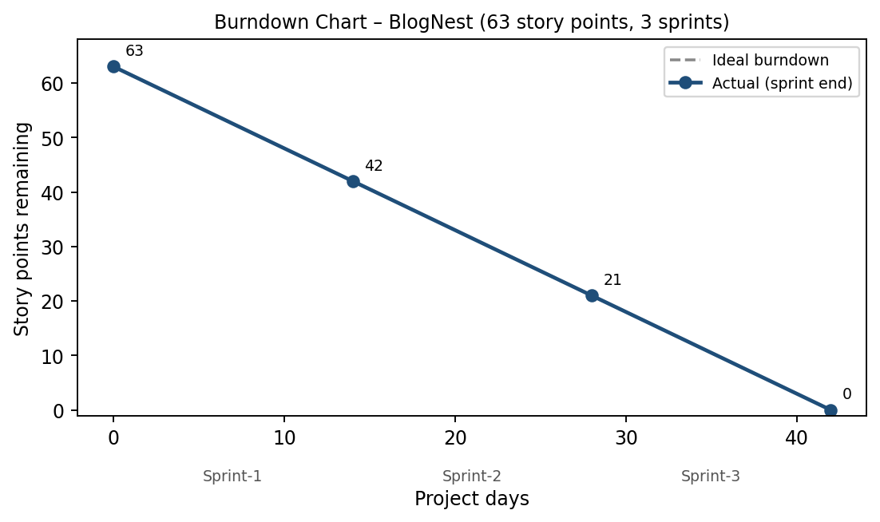

References:
- https://www.atlassian.com/agile/project-management

- https://www.atlassian.com/agile/tutorials/burndown-charts

- https://www.atlassian.com/agile/tutorials/sprints

- https://www.atlassian.com/agile/project-management/estimation

